## measuring and describing health

## why are people in poor countries

## living longer?

**Variations in Health:** Describe the variations in health as reflected by changes in life expectancy at national and global scales since 1950.  
Explain the patterns and trends in terms of differences in income and lifestyle.

**Measuring Health:** Evaluate life expectancy, infant mortality rate (IMR) and child mortality, HALE (health-adjusted life expectancy), calorie intake, access to safe water and access to health services as indicators of health.

**Food and Health**

Measurements of health – positives and negatives

Life expectancy at birth

Age specific life expectancy

Infant mortality rate (IMR)

Child mortality

HALE (health-adjusted life expectancy)

Calorie intake

Access to safe water

Access to health services

DALY (and DALE)

The big picture

Patterns:

Trends:

Explaining health: Income or lifestyle?

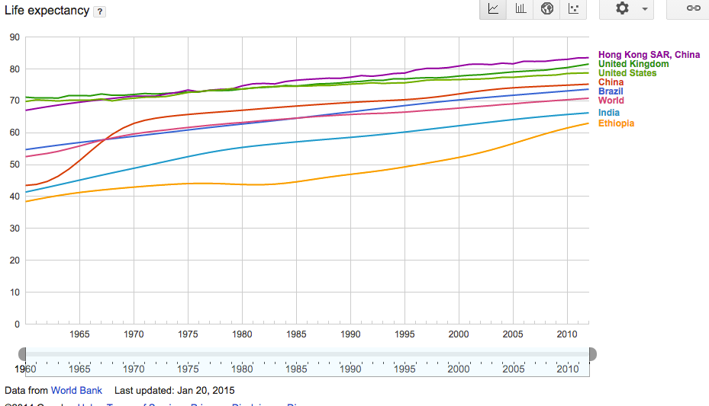

Source: http://www.google.co.uk/publicdata/explore?ds=d5bncppjof8f9_&ctype=l&strail=false&bcs=d&nselm=h&met_y=sp_dyn_le00_in&scale_y=lin&ind_y=false&rdim=region&idim=country:HKG:CHN:USA:ETH:IND:BRA:GBR&ifdim=region&tdim=true&hl=en_US&dl=en_US&ind=false

Summary of summary:

……………………………………….………………………………………….……………

Summary of today’s lesson

………………………………………….………………………………………….………………………………………….………………………………………….………………………………………….………………………………………….………………………………………….………………………………………….………………………………………….………………………………………….………………………………………….………………………………………….………………………………………….………………………………………….………………………………………….………………………………………….

Before next time:

Read textbook p255-259

“HALE is a more appropriate measure of overall health than any other.” Discuss this statement.

……………………………………………..………………………………………………………..

……………………………………………..………………………………………………………..

……………………………………………..………………………………………………………..

……………………………………………..………………………………………………………..

……………………………………………..………………………………………………………..

……………………………………………..………………………………………………………..

……………………………………………..………………………………………………………..

……………………………………………..………………………………………………………..

……………………………………………..………………………………………………………..

……………………………………………..………………………………………………………..

……………………………………………..………………………………………………………..

……………………………………………..………………………………………………………..

……………………………………………..………………………………………………………..

……………………………………………..………………………………………………………..

……………………………………………..………………………………………………………..

……………………………………………..………………………………………………………..

……………………………………………..………………………………………………………..

Key terms

Health

Life expectancy

HALE  
DALY

Calorie intake

Safe water

Access to health services

Starter activity: Describe the change in life expectancy for ONE country in the graph.

……………………………………………..………………………………………………………..

……………………………………………..………………………………………………………..

……………………………………………..………………………………………………………..

……………………………………………..………………………………………………………..

……………………………………………..………………………………………………………..

……………………………………………..………………………………………………………..