Your final assessment: Is prevention better than the cure?

……………………………………………..………………………………………………………..……………………………………………..……………………………………………………..……………………………………………..………………………………………………………..……………………………………………..………………………………………………………..……………………………………………..………………………………………………………..……………………………………………..………………………………………………………..……………………………………………..………………………………………………………..……………………………………………..……………………………………………………..……………………………………………..………………………………………………………..……………………………………………..………………………………………………………..……………………………………………..………………………………………………………..……………………………………………..……………………………………………………………………………………………………..………..

Prevention: the disadvantages

Why neither works

Curative treatment: the disadvantages

Cure outweighs prevention

Prevention outweighs cure

Balanced approach

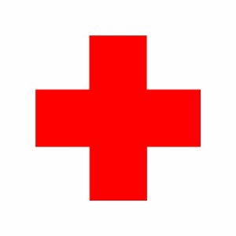

Curative treatment: the advantages

Prevention: the advantages

Before next time:

Read Course Companion p255-259 as a review of the issues so far. Make sure you have notes on every aspect covered in the book.

Summary of summary:

……………………………………….………………………………………….…………………………………………………….…………………………………………………….…………………………………………………….……………

Summary of today’s lesson

………………………………………….………………………………………….………………………………………….………………………………………….………………………………………….………………………………………….………………………………………….………………………………………….………………………………………….………………………………………….………………………………………….………………………………………….………………………………………….………………………………………….………………………………………….………………………………………….

Starter activity: Have you been ill? What was the most effective way of dealing with your illness – prevention or cure? Is it affected by any geographical factors and, if so, what are they?

……………………………………………..………………………………………………………..……………………………………………..……………………………………………………..……………………………………………..………………………………………………………..……………………………………………..………………………………………………………..……………………………………………..………………………………………………………..……………………………………………..………………………………………………………..

Key terms

Primary healthcare

Preventative

Curative

Communicable disease

Non-communicable disease

## prevention relative to treatment

## drug companies want to make you better while governments want to keep you from getting ill: true or false?

Pre

**Prevention relative to treatment**

Discuss the geographic factors that determine the relative emphasis placed by policy-makers, in one country or region, on prevention as opposed to treatment of disease.

**Food and Health**