Before next time:

Read p266-7, Oxford Course Companion for Geography (2011)

Summary of summary:

……………………………………….………………………………………….……………

The Green Revolution – history, benefits, and problems

Ways to increase food production (aside from the Green Revolution)

SPEED factors affecting food insecurity

How is food security different to calorie intake?

Global patterns of food security

So, why aren’t you starving?

……………………………………………..………………………………………………………..

……………………………………………..………………………………………………………..

……………………………………………..………………………………………………………..

……………………………………………..………………………………………………………..

……………………………………………..………………………………………………………..

……………………………………………..………………………………………………………..

……………………………………………..………………………………………………………..

……………………………………………..………………………………………………………..

……………………………………………..………………………………………………………..

……………………………………………..………………………………………………………..

……………………………………………..………………………………………………………..

……………………………………………..………………………………………………………..

……………………………………………..………………………………………………………..

……………………………………………..………………………………………………………..

……………………………………………..………………………………………………………..

……………………………………………..………………………………………………………..

……………………………………………..………………………………………………………..

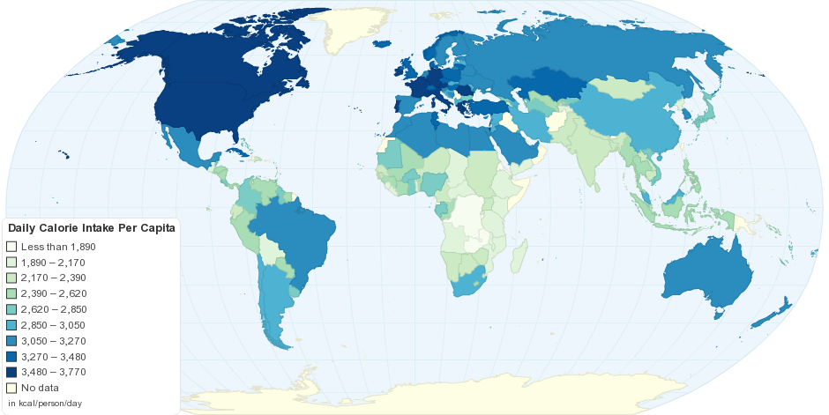

Summary of today’s lesson

………………………………………….………………………………………….………………………………………….………………………………………….………………………………………….………………………………………….………………………………………….………………………………………….………………………………………….………………………………………….………………………………………….………………………………………….………………………………………….………………………………………….………………………………………….

**why aren’t you starving?**

**GLOBAL AVAILABILITY OF FOOD and**

**AREAS OF FOOD SUFFICIENCY AND DEFICIENCY**

**Food and Health**

Key terms

Malnutrition

Temporary hunger,

Chronic hunger

Famine

Food security

Food insecurity

Starter activity: Describe calorie intake according to the map.

……………………………………………..………………………………………………………..

……………………………………………..………………………………………………………..

……………………………………………..………………………………………………………..

……………………………………………..………………………………………………………..

……………………………………………..………………………………………………………..

……………………………………………..………………………………………………………..

Global availability of food

* Identify global patterns of calorie intake as one measure of food availability.
* Distinguish between malnutrition, temporary hunger, chronic hunger and famine.
* Discuss the concept of food security.

Areas of food sufficiency and deficiency

* Explain how changes in agricultural systems, scientific and technological innovations, the expansion of the area under agriculture and the growth of agribusiness have increased the availability of food in some areas, starting with the Green Revolution and continuing since.
* Examine the environmental, demographic, political, social and economic factors that have caused areas of food deficiency and food insecurity.