Varying disasters: in space, time, impact and intensity

|  |  |  |
| --- | --- | --- |
|  | In space | In time |
| Intensity |  |  |
| Impact |  |  |

Why is the concept of a disaster not completely objective? (Varying definitions of disaster.)

Methods used to measure the impact of disasters

Key terms

Hazard

Hazard event

Disaster

Impact

Intensity

Source: <http://www.emdat.be/sites/default/files/Trends/natural/world_1900_2011/kefyr1.jpg>

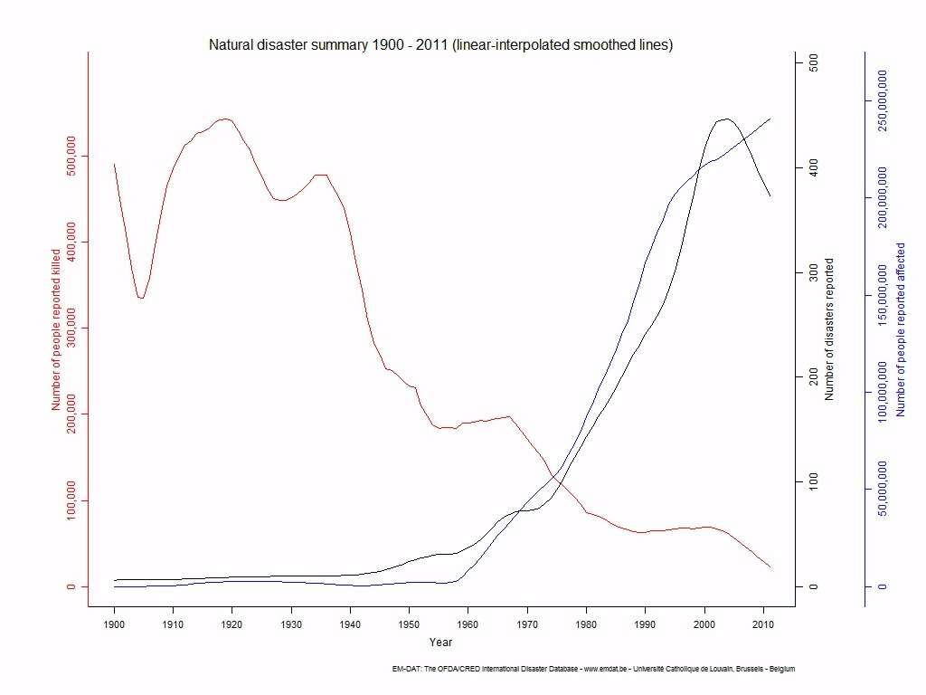

Summary of today’s lesson

………………………………………….………………………………………….………………………………………….………………………………………….………………………………………….………………………………………….………………………………………….………………………………………….………………………………………….………………………………………….………………………………………….………………………………………….………………………………………….………………………………………….………………………………………….………………………………………….

Starter activity: Compare the number of disasters reported and the number of people killed in disasters from 1900 to 2011.

……………………………………………..…………………………………….

……………………………………………..…………………………………….

……………………………………………..…………………………………….

……………………………………………..…………………………………….

……………………………………………..…………………………………….

“The description of an event as a ‘disaster’ is often inappropriate.” Discuss this statement.

……………………………………………..………………………………………………………..

……………………………………………..………………………………………………………..

……………………………………………..………………………………………………………..

……………………………………………..………………………………………………………..

……………………………………………..………………………………………………………..

……………………………………………..………………………………………………………..

……………………………………………..………………………………………………………..

……………………………………………..………………………………………………………..

……………………………………………..………………………………………………………..

……………………………………………..………………………………………………………..

……………………………………………..………………………………………………………..

……………………………………………..………………………………………………………..

……………………………………………..………………………………………………………..

……………………………………………..………………………………………………………..

……………………………………………..………………………………………………………..

……………………………………………..………………………………………………………..

……………………………………………..………………………………………………………..

……………………………………………..………………………………………………………..

……………………………………………..………………………………………………………..

……………………………………………..………………………………………………………..

……………………………………………..………………………………………………………..

Before next time:

Complete all work up to date! Bring in your notes so far to the next lesson.

Summary of summary:

……………………………………….………………………………………….……………

## WHEN IS A DISASTER NOT A DISASTER?

## defining and measuring disASTERS

Definition

* Distinguish between a hazard event and a disaster.
* Explain why this distinction is not always completely objective.

Measuring disasters

* Describe the methods used to quantify the spatial extent and intensity of disasters.
* Examine the ways in which the intensity and impacts of disasters vary in space and have changed over time.

**Hazards – risk assessment and response**