|  |  |  |  |
| --- | --- | --- | --- |
|  | **Community** | **National** | **International** |
| During |  |  |  |
| After |  |  |  |
| Limiting factors? |  |  |  |

The difference between Rescue, Rehabilitation and Reconstruction

Model of disaster response for urban areas

Source: http://hazards.umwblogs.org/files/2010/01/disaster-recovery-diagram.png

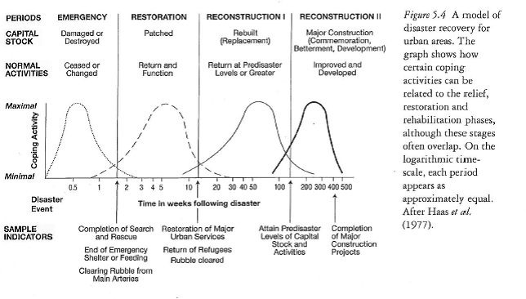

Key terms

Rescue

Rehabilitation

Reconstruction

Adjustment

Response

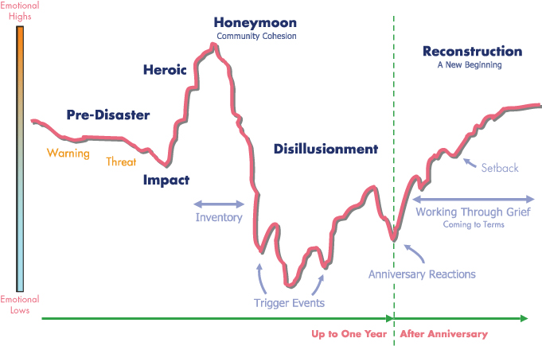

Source: http://www.peakoilblues.org/blog/2011/03/16/the-psychology-of-disaster/

Examine the reasons why community responses to hazard events are sometimes ineffective.

……………………………………………..………………………………………………………..

……………………………………………..………………………………………………………..

……………………………………………..………………………………………………………..

……………………………………………..………………………………………………………..

……………………………………………..………………………………………………………..

……………………………………………..………………………………………………………..

……………………………………………..………………………………………………………..

……………………………………………..………………………………………………………..

……………………………………………..………………………………………………………..

……………………………………………..………………………………………………………..

……………………………………………..………………………………………………………..

……………………………………………..………………………………………………………..

……………………………………………..………………………………………………………..

……………………………………………..………………………………………………………..

……………………………………………..………………………………………………………..

……………………………………………..………………………………………………………..

……………………………………………..………………………………………………………..

……………………………………………..………………………………………………………..

……………………………………………..………………………………………………………..

……………………………………………..………………………………………………………..

……………………………………………..………………………………………………………..

Summary of today’s lesson

………………………………………….………………………………………….………………………………………….………………………………………….………………………………………….………………………………………….………………………………………….………………………………………….………………………………………….………………………………………….………………………………………….………………………………………….………………………………………….………………………………………….………………………………………….………………………………………….

Starter activity: What would affect your personal response to a hazard event in your area?

……………………………………………..…………………………………….

……………………………………………..…………………………………….

……………………………………………..…………………………………….

……………………………………………..…………………………………….

……………………………………………..…………………………………….

Before next time:

Exam question! Complete by hand in 40 minutes.

Summary of summary:

……………………………………….………………………………………….……………

## what do people do after a disaster?

2. Distinguish between rescue, rehabilitation and reconstruction responses.

1. Describe the range of responses, at the community, national and international levels, during and after a hazard event or disaster.

5. Examine the factors that affected the choice of adjustments before, and responses to, actual hazard events or disasters.  
3. Explain how these responses are affected by individual and community perceptions.  
4. Discuss the importance of re‑assessing risk, and re‑examining vulnerability, following any major hazard event or disaster.

*Note: The order described here is the order we will cover these together. The numbers relate to the order they appear in the syllabus.*

**Hazards – risk assessment and response**